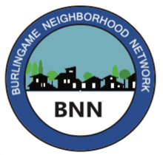

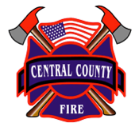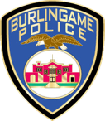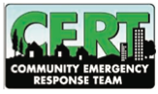A group of people standing outside


Your advance sign-up is appreciated. Just email:

Janice Barry, [jb@yahoo.com](mailto:jb@yahoo.com)

or Justin Cambry, [jcmb@gmail.com](mailto:jcmb@gmail.com)

At this outdoor event masks are encouraged, and County Covid guidelines will be followed.

This citywide Drill is held simultaneously in dozens of neighborhoods throughout Burlingame, with hundreds of residents participating. It is organized by Burlingame Neighborhood Network, with support from our partners:

In just 90-minutes

see how emergency teams organize.

We’ll practice how to respond

to hazards emerging from a mock earthquake

to protect our block and each other.

You’ll learn and have fun - and kids are welcome.

Fire & Police Department teams may visit.

Citywide

Disaster Response Drill

**Saturday, October 9**

**9:00 – 10:30 am**

Come team with your Los Robles neighbors!

Meet for our drill at

**2222 Los Robles Drive**